Open Core DRAW. Draw the circle using ellipse tool, fill it with white color. Start drawing petal around the cirle using bezier tool. Fill the shape with white color.
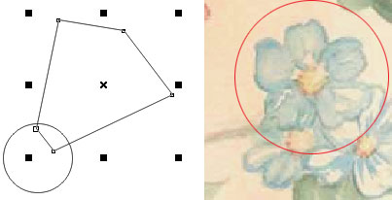
2. Convert the shape to curve and start editing the shape using shape tool.
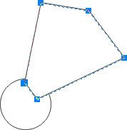
3. Using nodes and bezier handles to edit the shape.
4. Draw another shape with reference to the sample artwork. Fill it with white color, edit with shape tool after converting it to curve.
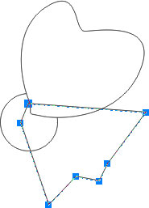
5. Continue drawing the shapes for petals and edit them using shape tool. You can move and adjust the shape using pick tool.
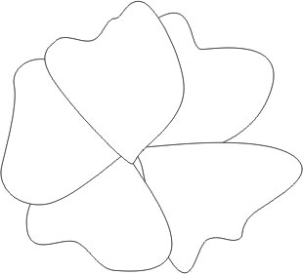
6. Select pick tool. Drag in the middle protion. Do not touch any of the petal. Just start dragging from the left to right so as to cover the hidden circle behind the petal. With this, we are going to select the hidden corcle.
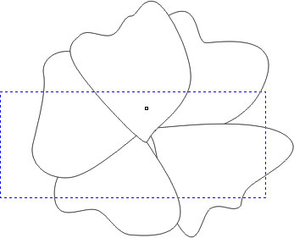
7. The circle is selected. Keep it selected.
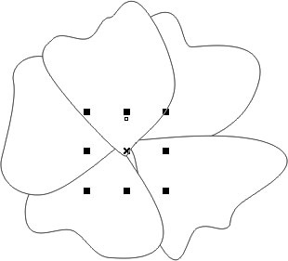
8. Arrange > Order > To Front of Page
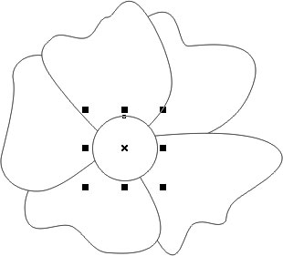
9. Adjust the circle and the shapes using pick tool.
10. Export the drawing to photoshop for painting.

